
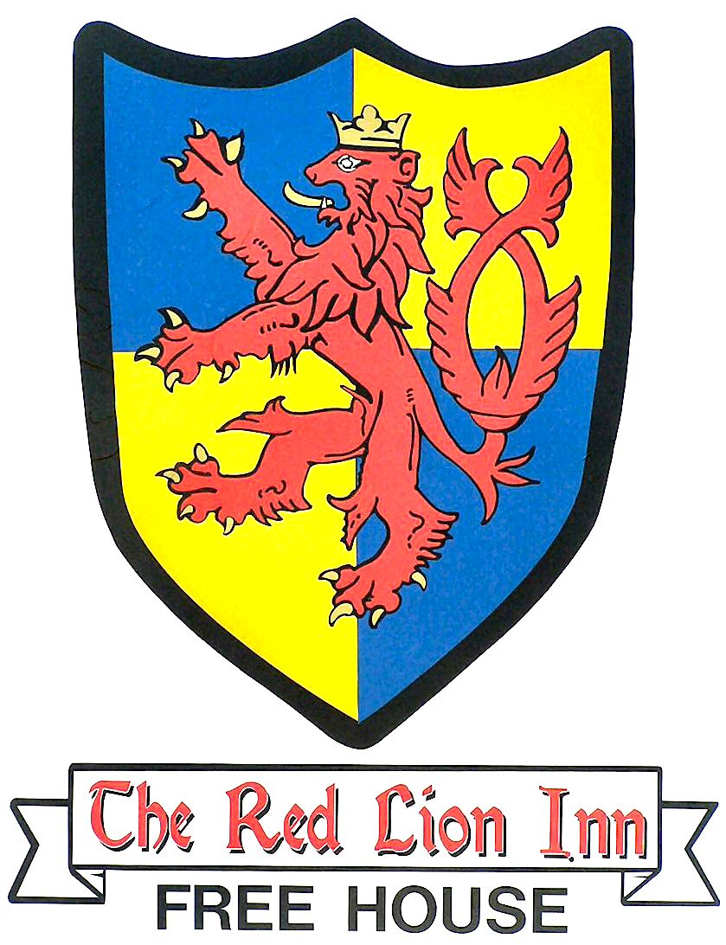
CUSTOMER TO KEEP THIS PART

Event booked | No. of tickets: |  | Cost (at £30 each)
BT09S
24th Oct 2009
BT09B
21st Nov 2009
BT10L
20th Feb 2010
BT10V
20th Mar 2010
Total payment £ . . . . . . . . . . . . . . . . . . . .

METHOD OF PAYMENT

A) Payment at Red Lion:
Ensure that this section is stamped, signed and dated by bar staff

B) Cheque made out to J SIMPSON and form posted to
MCCW, 56 Greenacres, Shoreham-by-Sea BN43 5WY.
Cheque number: |  | Date sent :

Your ticket(s) will be posted to you and should arrive within 15 working days. In case of queries telephone MCCW at 01273 454006
Or email cheers@simpson.uk.com
Beer Tastings
at The Red Lion
Old Shoreham 2009-10

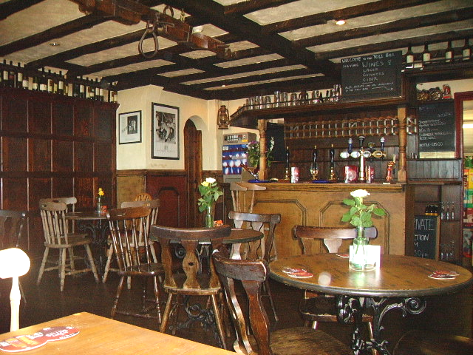
This autumn sees a new series of beer tasting courses run by John & Jeannette Simpson. We are delighted that we will again be offering them in conjunction with the Red Lion, Old Shoreham Road, Shoreham-by-Sea. This 16th century coaching inn is a perfect venue, with great atmosphere, and an excellent reputation for food and real ales. This enables us to start each tasting with lunch (included) and those who like to prolong the session after the tasting officially finishes could not wish for a better location.

There will be three tastings and a special 5-course beer lunch. Each event will run from 12.00-16.00(ish). Note the earlier start time.
We suggest that you arrive a few minutes before 12.00 for the tastings then you can sit with a beer (included) and choose your lunch before we start. As always, we stress that you must not drive after these sessions, and the Red Lion is well provided for public transport with a bus stop outside the door and Shoreham train station just a short walk away. If you are arranging a lift home we suggest you book your transport no earlier than 16.30.

In spite of costs increasing all round, we've managed to hold the price at the same level as last year, that is £30, which includes all the beer samples in the programme (at least 15, usually 20+) as well as lunch and mid-afternoon snack. The latter was originally intended to be just nibbles, but, as those who came to the previous tastings will know, Natalie tends to be very generous in her interpretation of 'nibbles'!

Book early to be sure of a place. Complete all sections of this form, then
either hand it in at the bar of the Red Lion, being sure to retain your receipt,
or post the booking form to MCCW with your cheque, keeping the receipt portion with details of your cheque and date sent.
Your ticket(s) will be posted to you and should arrive within 15 working days. In case of queries, contact MCCW as shown on the receipt.
RETURN THIS PART WITH PAYMENT
To book places either
- hand in the completed form at the Red Lion with your payment or
- send it with your cheque, made out to J SIMPSON, to:
MCCW, 56 Greenacres, Shoreham-by-Sea, West Sussex BN43 5WY.

Please send me tickets for the tastings as indicated below:
Tasting | No. of tickets: | Cost (at £30 each)
BT09S
24th Oct 2009
BT09B
21st Nov 2009
BT10L
20th Feb 2010
BT10V
20th Mar 2010
I enclose my cheque/cash for the total amount of £ . . . . . . . . . . . . .
Name:
Address:

Tel.No/Email:
Signed: |  | Date:

Beer Tastings at the Red Lion, Old Shoreham Road, Shoreham-by-Sea.

Each event will run from 12.00-16.00(ish). Note the earlier start time. We suggest that you arrive a few minutes before 12.00 for the tastings then you can sit with a beer (included) and choose your lunch before we start. As always, we stress that you must not drive after these sessions, and the Red Lion is well provided for public transport with a bus stop outside the door and Shoreham train station just a short walk away. If you are arranging a lift home we suggest you book your transport no earlier than 16.30.

Saturday 24th October 2009 SURPRISING BEERS! Ref BT09S
That is, 'surprise' as in 'nice surprise' not 'nasty shock'! These include surprisingly good beers from parts of the world not normally known for their brewing skills, beers including unusual ingredients, and beer styles different from what you are used to. Approach this session with an open mind and prepare to have your beer horizons broadened!

Saturday 21st November 2009 MASTER BREWERS OF BELGIUM Ref BT09B
Just when you think you're getting to know Belgian beers you suddenly find that new breweries have appeared or existing breweries have brought out new beers. For those of you who have attended Belgian tastings before we can assure you that this session will introduce you to new breweries and a lot of exciting new brews. Will any of them find a place among the Belgian classics in the future?

Saturday 20th February 2010 ADUR BEER LUNCH Ref BT10L
This is an exciting new development in which we will showcase the beers of the local Adur Brewery. We will start with a beer as we gather then the meal will consist of 5 courses - appetiser, soup, main (including vegetarian option), cheese and dessert. Each course will be accompanied by the appropriate beer from the Adur range and/or include beer as an ingredient. Forget anything you've heard about pretentious and extortionately priced 'beer cuisine' - the price for the whole event (5 course meal plus all beers) is £30. And with the Red Lion's excellent reputation for quality and value you can anticipate a tasty and very satisfying experience!

Saturday 20th March 2010 VERY SPECIAL BEERS Ref BT10V
This will be a rare, probably unrepeatable opportunity to taste beers that you may read about but seldom see. It will include aged beers, beers from limited (numbered) editions and beers normally supplied only to overseas markets where they can command a high price. These are beers of character, well-deserving their great reputation, although of widely different styles. The one thing they have in common is that they are all very expensive, many commanding the same price as fine wines! If want a chance to appreciate the pinnacle of the brewer's art book your tickets right away - this one-off opportunity is bound to sell out very quickly!

For more information and/or to sign up for a free e-newsletter see:
www.simpson.uk.com

